
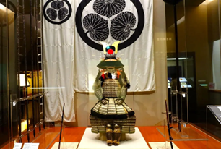





The 1st Call for Papers

The 21st International Conference on Precision Engineering

November 15-19, 2026, Winc Aichi, Nagoya, Japan
Website: https://www.scoop-japan.com/kaigi/icpe2026/
Contact: info-icpe2026@mae.nagoya-u.ac.jp
ICPE2026 Website

The 21st International Conference on Precision Engineering (ICPE2026 in Nagoya) will be organized by the Japan Society for Precision Engineering (JSPE) and the Tokai Branch of JSPE. The conference will be held from November 15 to 19, 2026 in Nagoya, Japan, at Winc Aichi, located in front of Nagoya station.

Focus of the conference:
(1) Digital design and manufacturing systems
(2) Life cycle and smart engineering
(3) Advanced system design and applications
(4) CAD/CAM technologies
(5) Advanced cutting technologies
(6) Advanced grinding technologies
(7) Tribology
(8) Micro/Nano machining and figuring
(9) Nano-scale surface finishing
(10) Non-traditional machining and additive manufacturing
(11) Energy beam processing
(12) Advanced die/molding and polymer processing
(13) Forming
(14) Advanced machine tools and elements
(15) Micro systems and machine elements
(16) Robotics and mechatronics
(17) Ultra precision controls
(18) Nano-scale measurements and calibrations
(19) Surface metrologies of Nano-scale structures
(20) Mechano photonics engineering and optical applications
(21) Advanced image processing and applications
(22) Advanced 3-dimensional digital processing
(23) Advanced surface processing
(24) Micro fabrications for functional surfaces
(25) 3D/4D printing of functional products with embedded sensors and actuators
(26) MEMS/NEMS
(27) Bio-medical engineering and applications
(28) Bio-inspired design methods
(29) Optical metrology for precision engineering
(30) Dimensional measurement and instrumentation
(31) Atomic and close-to-atomic scale manufacturing
(32) Machine tool calibration
(33) Precision positioning
(34) Big data analytics in zero-defect machining scheduling
(35) Artificial intelligence and machine learning in precision engineering
(36) Cyber-physical production systems
(37) Human-robot collaboration and brain robotics in precision assembly
(38) Adaptive process planning and quality control in precision engineering
(39) Semiconductor manufacturing and metrology
ICPE2026 Nagoya
The research field is not limited to the above topics.

Important dates for paper submission:

Types of Papers: Authors are invited to submit either an Extended Abstract (4–6 pages including figures and tables) or a Short Paper (2 pages including figures and tables). Both formats will be available for download to registered participants only.
• Submission of 100 -200-word abstract: January 1 - March 27, 2026
• Notification of abstract acceptance: April 20, 2026
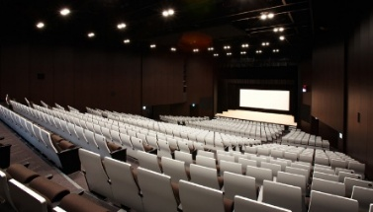
• Submission of manuscript for paper review: May 29, 2026
• Notification of paper acceptance: June 29, 2026
• Submission of Camera-ready manuscript: July 31, 2026

Main conference schedule:
• Welcome reception: November 15, 2026
• Conference: November 15 – 19, 2026
• Banquet: November 17, 2026
• Factory tour: November 19, 2026 Winc Aichi, Nagoya

Location:
Nagoya locates in the center of Japan and offers spectacular access to the main tourism hubs around the country for guests in Japan and from overseas. The city is home to a variety of famous historic, gourmet, and photogenic spots as well as hands-on experiences allowing you to discover Nagoya’s tradition and manufacturing prowess.
• From Tokyo to Nagoya: About 1.7 h and from Osaka: About 0.8 h by Shinkansen

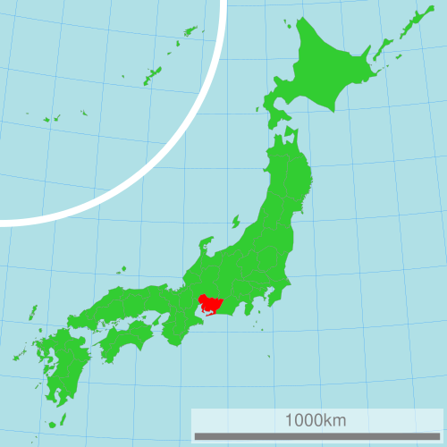
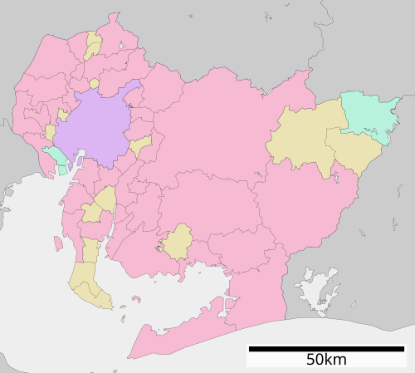
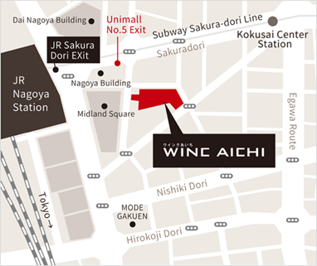
Nagoya, Aichi
Nagoya, Aichi
Osaka
Tokyo
Kyoto
Sendai
Hokkaido

Conference Committee:
• General Chair Prof. Yoshimi Takeuchi, Chubu University
• Conference Chair Prof. Hirofumi Suzuki, Chubu University
• Conference Co-chairs Prof. Seiichi Hata, Nagoya University
Prof. Katsushi Furutani, Toyota Technological Institute
Prof. Fumihiro Itoigawa, Nagoya Institute of Technology

Special Issue to International Journals:
Outstanding Extended Abstract may be recommended for publication in the following journals:
• Journal of the International Societies for Precision Engineering and Nanotechnology (PE)
• International Journal of Automation Technology (IJAT), published by Fuji Technology Press

Conference registration fees:
 | Early registration up to August 28, 2026  (JSPE member / Non-member) | Late registration after August 28, 2026  (JSPE member / Non-member)
Regular | 80,000 / 95,000 JPY | 85,000 / 100,000 JPY
Student | 60,000 / 75,000 JPY | 65,000 / 80,000 JPY
Welcome reception and banquet are included.

ICPE2026 Nagoya

